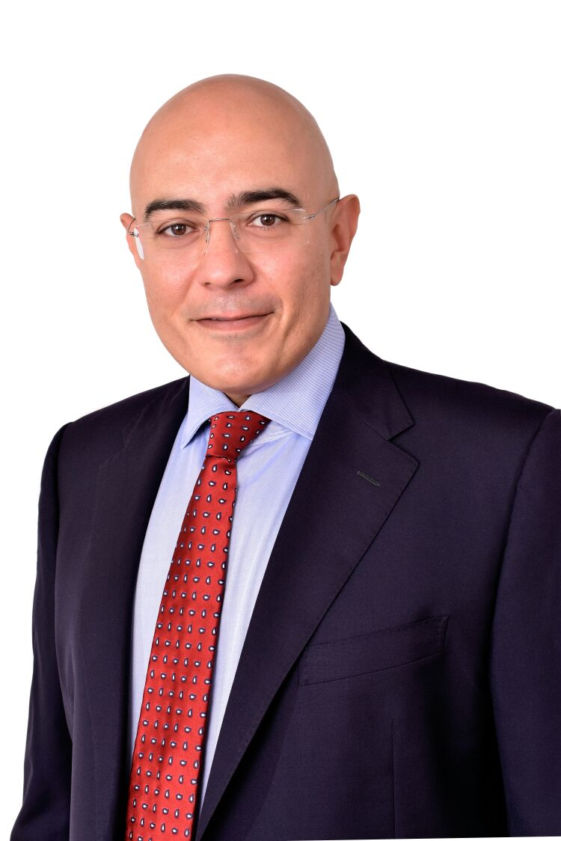 | Aghiath CHBIB  Co-founder of Telebionix  Moorpark, California, USA  Board Member  of Global Cybersecurity Association

Aghiath is co-founder of Telebionix a MedTech innovation company based in California. Telebionix is transforming the future of healthcare by creating intelligent, AI-driven, easy-to-use clinical grade remote devices that will dramatically increase access to care and save lives.

He is also founder of SEECRA a Dubai based company providing Cybersecurity, Digital Forensics and Blockchain consultancy and pioneer solutions in collaboration with the engineering universities and research centers to safeguard governments, financial institutions and other enterprises from cyberthreats.

A serial entrepreneur, Aghiath is recognised as a Top 50 Global Thought Leader and Influencer.

Aghiath is a Board Member of Global Cybersecurity Association and an Advisory Board Member of CEH (Certified Ethical Hacker) and of TechABC UK.

He is an Author for Intelligenthq, bizcatalyst360, Openbusinesscouncil, and Hedgethink.

