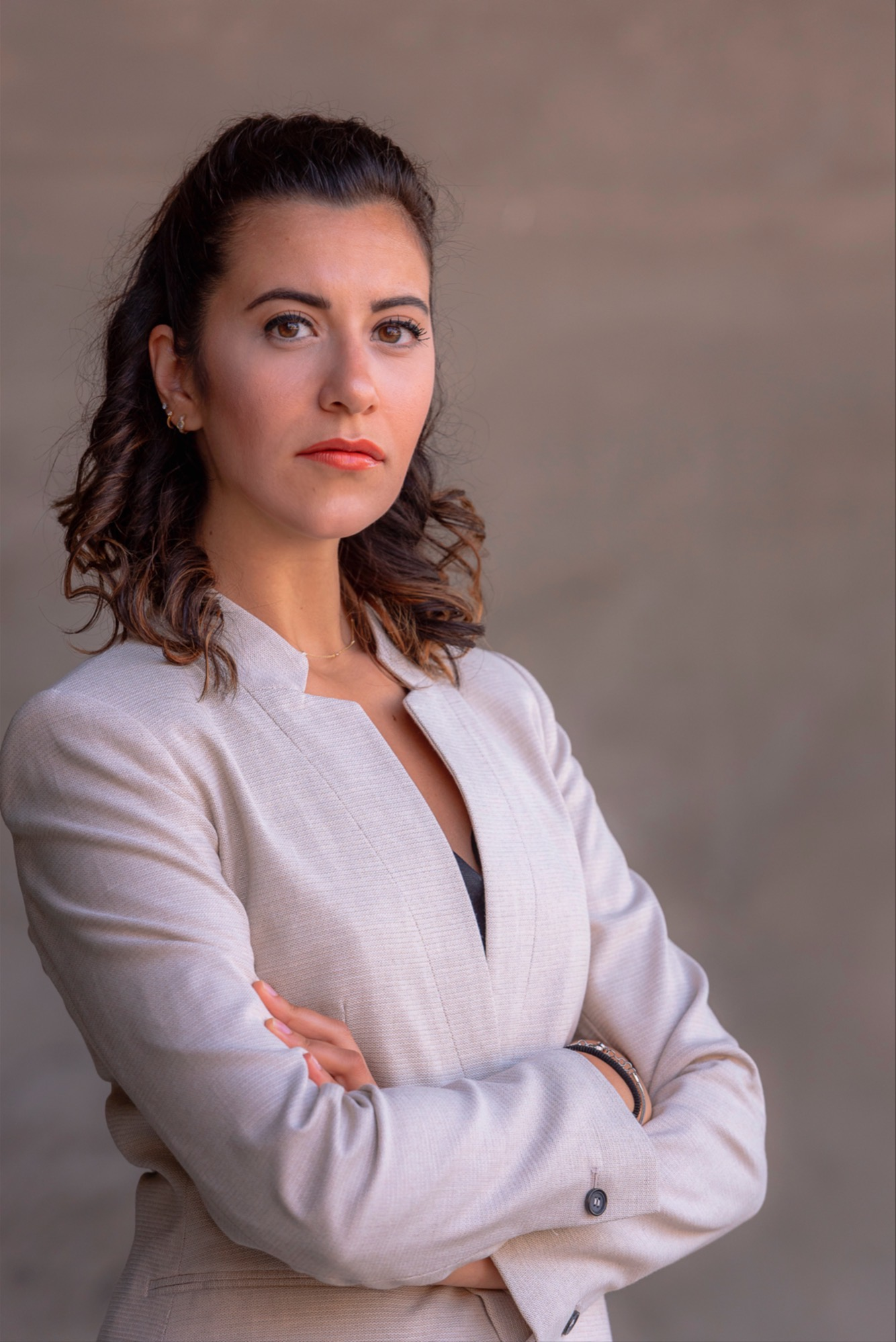 | Federica VITALE  Certified Information Privacy Professional, Europe, by the International Association of Privacy Professionals  Data Privacy & GDPR Officer  At the Global Cybersecurity Association

Federica Vitale is a Certified Information Privacy Professional, Europe by IAPP (International Association of Privacy Professionals), a published co-author of the book “The Rise of Cyber Women: Volume Two” and aspiring US attorney applicant.

At Global Cybersecurity Association, Federica is Data Privacy and GDPR Officer, advising on European Data Protection Law, GCA’s privacy policies and internal compliance.

She is currently pursuing an LLM - Master of Laws in Privacy Law and Cybersecurity with certificate in Technology and Entrepreneurship at the University of Southern California Gould School of Law, one of the premier USA universities in this field and where she received the Dean’s Academic Excellence Award. Upon successful completion of her LLM at USC Gould, Federica will have expertise on EU and USA Privacy Law.

Prior to joining USC Gould as a graduate student, Federica was the Compliance, Risk and Data Privacy Associate for a tech company in the UK specialized in the collection of geospatial data, where she worked on internal, external and international compliance, alongside the company’s Data Protection Officer.

While she was pursuing her legal studies at Robert Gordon University, Aberdeen, UK, Federica was Director of a Legal Clinic in Scotland where she was in charge of a team of more than 70 volunteers and where she provided pro bono legal advice to members of the public under the supervision of solicitors.

At Global Cybersecurity Association, Federica is Data Privacy and GDPR Officer, where she deals with the assessment of data protection risks, she supports in the compliance with GDPR and where she liaised with the members of the Board.

